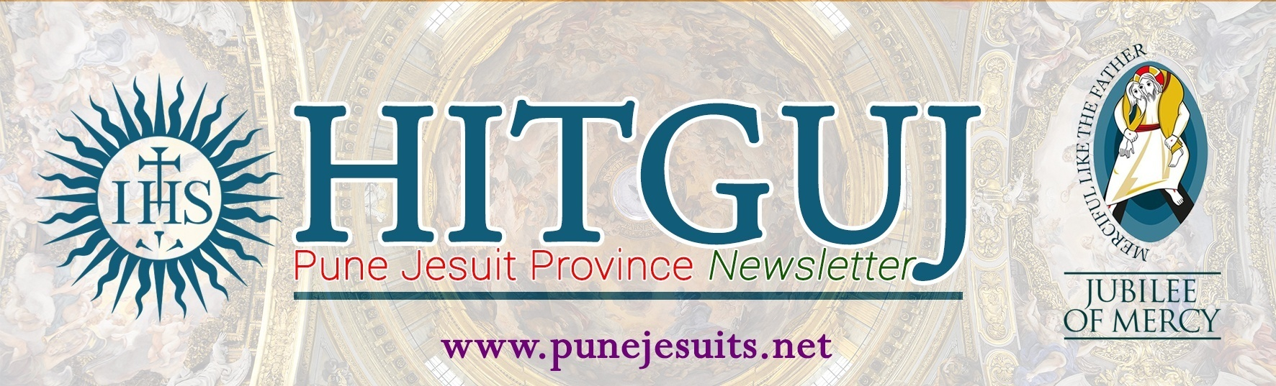
PUNE MARCH 2020 VOL.75/3
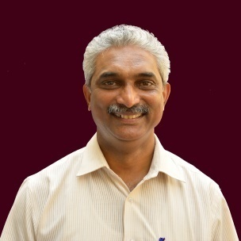
Dear Friends,

Financial administration in the Society is both spiritual and apostolic. It is animated by a sense of religious - apostolic service and by a spirit of solidarity and participation with those in greatest need. Thus, the budget is an instrument that seeks to identify strategies to support the administrative unit’s effort and to identify the sources from which the necessary resources will be available. Budgeting is a spiritual exercise; it is important to follow proper process of planning our resources systematically and making optimum use of it for the greater glory of God. I am grateful to all for keeping the spirit of the Society in discerning the budget of your community and apostolates. It is essential that we keep our accounts transparent and complete them in time.

Budgeting is a time of planning the allocation of our resources to achieve our mission priorities. While working out our budgets, we keep in view the resources we have invested in the past and those we plan to allocate to the various priorities of our Mission. We also take into account various other factors besides financial. By budgeting well, we are laying a solid foundation for our mission, as wise stewards, responding to God’s call in service of the people entrusted to our care. Evangelical poverty in the Society of Jesus is apostolic, prophetic, and the unequivocal condition of our credibility. It should be adapted to our times by becoming genuine, hardworking, committed and generous.

Transparency and accountability enables our mission to be dynamic and lively. Such a dynamic mission becomes a channel of God’s grace, grace to encounter God and to God’s people. This kind of enriching experiences rejuvenates our spirit to dedicate ourselves for God’s mission. It is God who calls and commissions us and accompanies us with His mission. So, we need to trust and experience God’s providence in our mission, as stewards of His gifts and resources.

Thus, Lent is the time of grace; it is preparing ourselves through prayers, fasting and almsgiving for the celebration of Easter with our Risen Lord who conquered sin and death by his suffering, death and Resurrection. Our spiritual and apostolic preparation enables us to discern God’s will in our life. Prayerful preparation enables us to open ourselves before God to be what God wants us to be. As we grow in our accountability and transparency in the mission, let the vision of the Founding Fathers encourage us to carry forward God’s mission, to experience our mission from God’s perspective. The comprehensive vision of our mission will enable us to trust in God so that the Mission of God becomes God’s providence. Let this Lenten season help us in the process of discerning our apostolic priorities and give witness to God’s love. Fr. General invites us to be guided by the Spirit just as Abraham did. To be guided by the Spirit means to grow in union with God. Then we will believe in God’s providence that God’s grace is sufficient for us.
Andrew Fernandes, SJ

PROVINCIAL’S PROGRAMME

MARCH

07: DJH Meeting
10: Budget Meeting
12: Visitation to Pathardi
13: Visitation to Shevgaon
24: Province Consult
28: Province Apostolic Committee meeting

AROUND THE PROVINCE

VIDYAJYOTI TIDINGS -:
The complexity of feelings and lasting memories of February with its experiential goodness and sadness seems overwhelming since the impact of those experiences have gone deep down in our minds and hearts.

On Feb. 17 & 18, the Vidyajyoti College had organized a two days seminar and the endowment lecture in honor of Profs. S. Arockiasamy SJ and Samuel Rayan SJ. The theme of the seminar was, “seeking God experience” the goal of theology by renowned theologian, Dr. Michael Amaladoss SJ. The participants from the RTCs and NTC presented their papers with the various relevant themes in five panels and involved with a lot of interaction in groups.
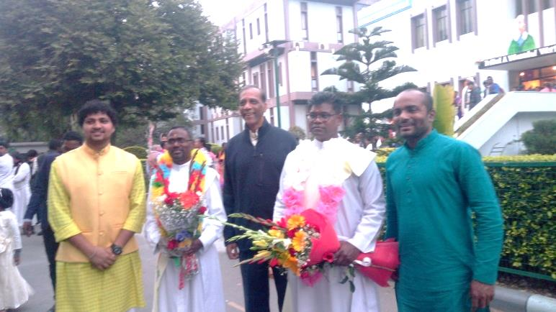The long-awaited event of the diaconate ordination of our twenty-eight brothers brought delights to all the community members as everyone played their roles successfully. On 22 February, the deacons of the ten Jesuit provinces of India entered into new mode of their vocation that is just a step near to the priestly ordination. The theme of the diaconate ordination, to heal the wounded world was apt to the context that we live today. Most Rev. Anil Couto, the Metropolitan Archbishop of Delhi, through laying on of hands and prayer of consecration accepted the deacons to the ministry of the church. Fr. Rector and the three Jesuit Provincials along with two quarters of priests from the Delhi province and the diocese participated in the Holy Eucharist to make this event a blessing to our deacons. Many lay faithful witnessed the beautiful ceremony of the diaconate and left the deacons overwhelmed with their love and prayers. The banquet was placed in the Vidyajyoti community in the evening to share the joy of diaconate. The ministry of the wounded healers would draw bigger hope and place many challenges in coming years to bring them closer to our Master and the Lord.

Besides the pleasant cold of the passing winter and blooming of beautiful flowers of the season, the Capital of India also witnessed agony and cry of the marginalized and the oppressed. The state legislative election and the anti - CAA and NRC protests were two of the prominent talks of the time. In the last week of February, it was sad to see/ witness that the peaceful protest of the anti-CAA in some parts of Delhi was attacked by the divisive forces and vandalized the properties of the ordinary innocent people especially belonging to the minority community. The erupted violence caused nearly fifty lives and hundred were left injured. The plight of the victims was devastative and heart breaking at sight. The women and children were fear stricken and traumatized by the violence and horror of the evil forces. The Vidyajyoti College voluntarily joined hands with the local Samaritans and the Christian organizations to help the victims on various levels. The Principal, Fr. P. R. John has been active all the time in coordinating and approaching volunteers to support the royal cause of the suffering people. The college has formed the coordinating committee to help out at the relief work in two categories, especially in medical and education of children. The willingness and openness to work along with other social organizations for the relief work of riot stricken people opens up the new horizon of collaboration and solidarity for the better future of humanity. Let us pray for the justice, peace and hope to be prevailed in our country.
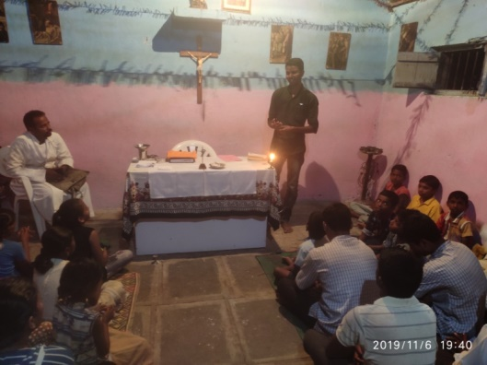
The academic year is a month closer to an end for the first- and second-year brothers but the deacons will have to close up their studies only in June and say goodbye to Vidyajyoti. We request all of you to continue to pray for us to do our Theological studies with vigor and faith and contextualize it in our day today life.
Sch. Sunil Gaikwad SJ

MY JOURNEY THROUGH THE EXPERIMENTS -:
Whenever I asked a Jesuit what was the best time of his life, his spontaneous reply was ‘NOVITIATE’. I used to wonder – why? But now after going through various types of experiment, I realized why it is the best time of our lives.

We the second year novices were sent to Shrirampur, Nasik and Belewadi for our Mission Experiment in groups of three. I, Vishal got the opportunity to be in Loyola Sadan parish, Shrirampur along with two of my novice companions, Noel and Ashley. Fr. Joe Gaikwad and Loyola Sadan Community gave us a hospitable stay and more than that, an epitome of inspiration. We stayed in villages like Umbargaon, Belapur, Padegaon and Davangaon in Chapels and people’s houses. Their hospitality filled our hearts with gratitude. We taught Catechism, shared our spiritual experiences, and conducted games and action songs for children. Organizing Bhajans was very much interesting. Their Bhajans deepened our long retreat experiences and Society’s mission of inculturation. We also conducted (LCD) “Let’s Celebrate Diwali” Camp in Loyola Sadan Parish. We tried to promote UAPs in small ways. The mission experiment really helped us to know and grow in our mission today, especially the preferential option for the poor.

The upcoming experiment was ‘seeking alms and walking pilgrimage to Bom Jesus Basilica, Old Goa.’ It was from 18th to 21st of November. We received God’s abundant graces, His protection and experienced divine providence as we walked towards Old Goa. Our first destination was Hemadga village. On the next day our journey was from Hemadga to Molem through Anmod ghats. We did feel tired and exhausted but the Rosaries, divine Mercy Chaplets and other vocal prayers made our journey joyful. The next day’s journey was from Molem to Fonda. The journey through the villages under the hot sun was very difficult. We experienced being rejected by people just like our Master. The pollution and garbage on the road made us feel more exhausted. In the evening we reached Fonda and took shelter at the local bus station for a night. Next day early in the morning, we began our journey towards our final destination - Finally after seeing the tall and proudly erected Augustine tower, our hearts were filled with vigour. After a three and half day’s journey, on 21st of Nov 2019 we reached our destination - Old Goa. After reaching Old Goa we had Thanksgiving Mass at the mausoleum of St. Francis Xavier. During the Novena days and the Feast day of St Francis Xavier we got the opportunity to render our service by doing various duties such as Communion Distribution, Mass writing, Ushering at the quos and so on. We were edified by people’s simple faith and devotion. St. Francis stood as an epitome of inspiration for us. His missionary zeal set our hearts on fire for God’s greater glory. We experienced a lot of spiritual graces and inspiration by lay people’s faith and their love for St. Francis Xavier. This pastoral experience helped us to deepen our faith.
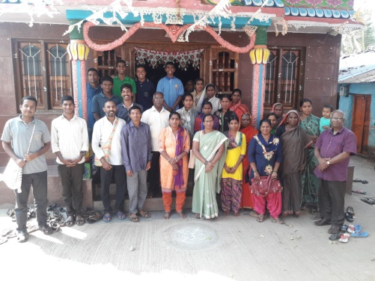
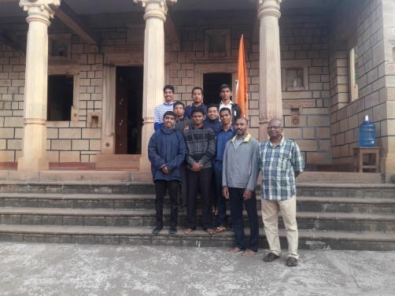
After celebrating Christmas and New Year in our Novitiate Community, we were sent for our next experiment that is the Hospital Experiment. Our experiment began on 13th January. We novices were sent in three different groups to three different hospitals - Missionaries of Charity Brothers (Borivali), Missionaries of Charity Sisters (Surat) and Helpers of Mary Sisters (Velholi). I was in “Mukta Jivan” Velholi, with my companions Joel and Swapnil. There we experienced God suffering in Leprosy patients, HIV affected people and the Senior citizens in old age home. The sisters of Helpers of Mary gave us a pleasant and hospitable stay. We worked in OPD, old age homes and Leprosy ward. In OPD, we helped in registration works and giving medicines to the patients who were mostly poor. In old age home we shaved their beards, fed them, lent a hand in small works and gardening, and most importantly to be with them and to console them. We understood that God did not want them to suffer, instead He himself suffered with them and He has chosen us to serve Him in these excluded and marginalized. The joy on these patients’ faces who have experienced so much of agony and rejection made us reflect over our own lives. We felt edified by their deep faith and joy. These experiments revived, nurtured and deepened our Long Retreat Experiences. It also helped us to get a deeper insight of what it means to be a Jesuit according to St. Ignatius.

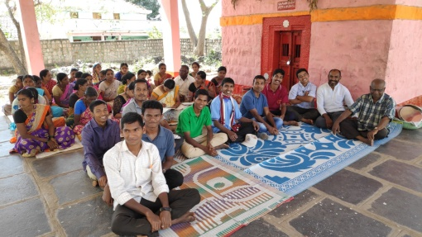
Meanwhile in the absence of the second year novices, we the first year novices had a week long study experiment at home in XTC. We worked in different groups – read, reflected and presented the present GC’s. After the presentation of recent GCs, we were sent to Nesargi for a Social Analysis Experiment conducted by Fr. Tom Chanakala and his team. This ten days programme was well organised specially for the novices. Initially Fr. Tom and his team gave us very informative sessions on ‘Kannada Mission and the work of Jana Jagran Samiti (Shramik Abhivruddhi Sangh). The Jana Jagaran team has been working for the empowerment of women through SHG’s, conducting awareness programmes about the government schemes like MGNREGA, vocation courses for girls and also giving interest free loans for their higher education without any barrier of cast and religion. As a part of our programme we were sent to different villages in pairs. We stayed with non-Christian families and participated in SHG meetings, clarified our queries, and learned the dynamics of SGH’s. We were touched by the hospitability of people. We also visited Deshnur ‘Virakta Mutt’ which is the best example of inculturation. We met Fr. Menino, the Incharge of the ‘Virakta Mutt’. Here in this Kannada mission Fr. Menino is known as Swami. We had the opportunity to participate in Holy Eucharist at the ‘Virakta Mutt’. It was an eye opener for us to see people of different religion attending the Mass with deep devotion and respect.
We came back to XTC full of inspiration, enthusiasm and missionary zeal. Indeed the social analysis programme challenged us for our future mission.
Novices: Vishal & Rushikesh

VINAYALAYA, JESUIT JUNIORATE -:

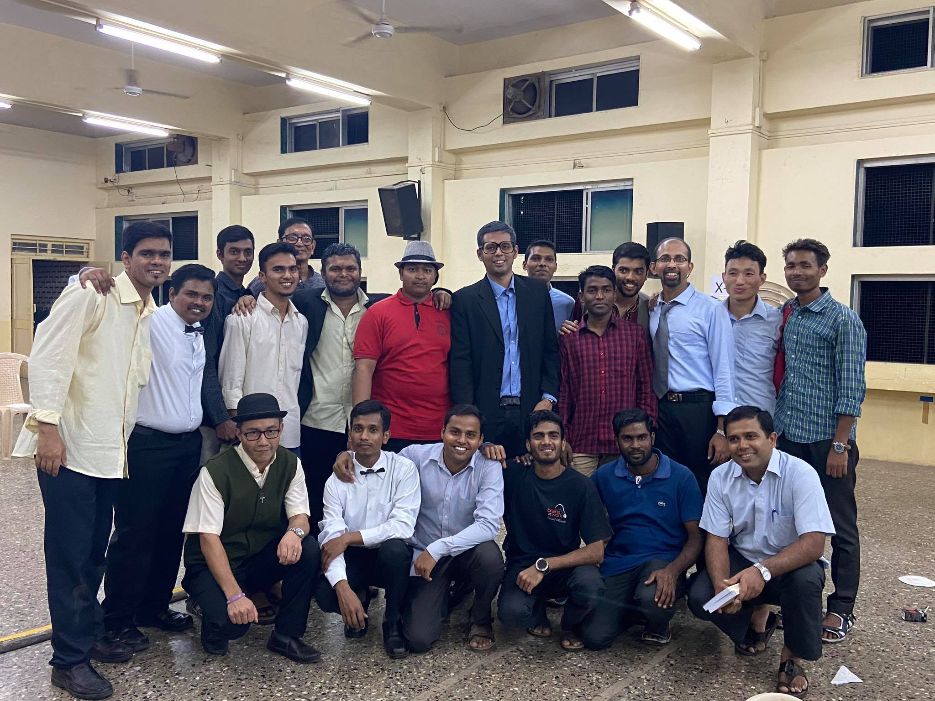
The last months were full of activities at Vinayalaya, Jesuit Juniorate. We had wonderful time in the last two months.
On 23rd January, we went to Chatrapati Shivaji Museum, Mumbai. It was the time to imbibe what we learnt in our history classes by Frs. Luke and Aubrey. With their guidance we could grasp the historical events, namely ancient and world history very easily. We also visited The Gateway of India on the same day. This visit helped us to understand the historical background of The Gateway of India.
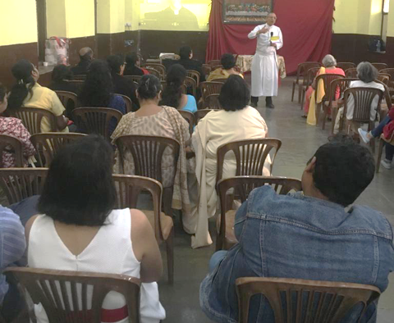
On 7th of February we went to Nasik for the Infant Jesus Shrine feast. We went to help out during the feast days. But this exposure helped us to deepen our call and faith in the Lord.

In the last two months we were busy preparing for our annual play ‘And then there were none’ by Agatha Christie. On 23rd February we put up our play at the Holy Family Higher Secondary School Hall. Our brothers worked in various committees to make this drama successful. This drama taught us how to be united and it also helped us in our language.
On 27th February we went to ‘Elephanta Caves’. The caves and the carvings were amazing. This was the time to learn more about ancient history and also to appreciate the carving arts.
Now we are preparing ourselves for the ASET exams and the Juniorate final exams. Kindly keep us in your prayers.
Bibi Antony

ST XAVIER’S PARISH, CAMP, PUNE -:
St. Xavier’s church witnessed a lot of activities in the last two months. As the New Year 2020 was ushered in, the Parish Priest, Fr. Kenneth Misquitta, SJ hosted the traditional Annual Parish volunteers dinner on the 6th of February for all the people serving the parish in different capacities. This dinner is not just an act of gratitude for the untiring commitment throughout the year but is also a moment to build fellowship and bonding.

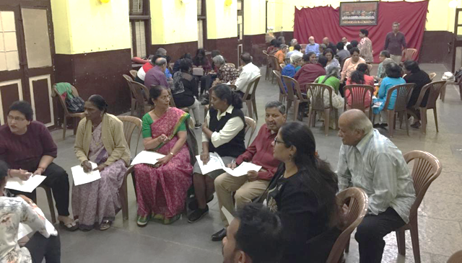
As we have entered in the season of Lent the communities (neighbourhoods, SSU and Youth) on a rotation basis prepare and conduct the Way of the Cross on Wednesdays and Fridays. Faith formation of the young is a priority and great concern today. On 9th February, Fr. Kenneth Misquitta, the Parish Priest conducted a session for the Catechetical teachers and the parents in imparting faith formation to the children. at Barco Hall The informative and profound session was well appreciated by the participants present.
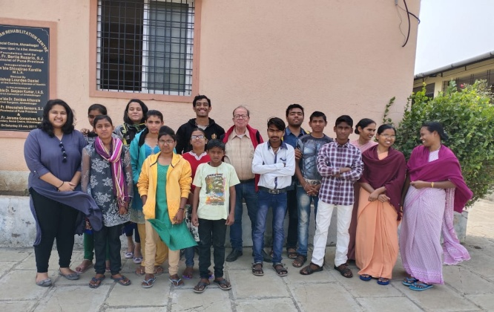
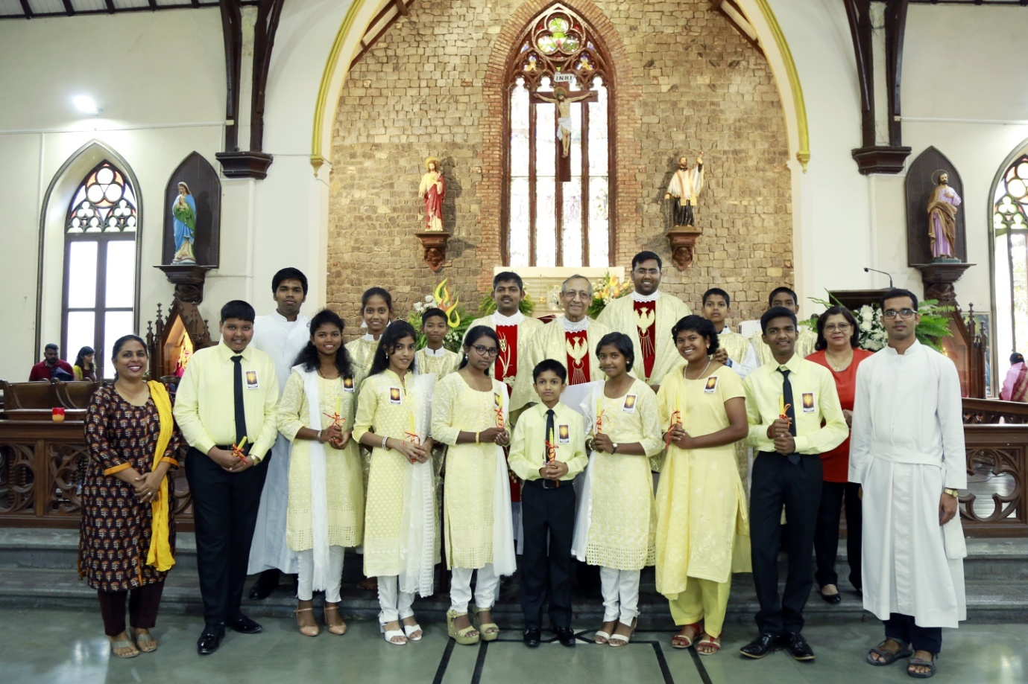
The Sunday school that takes care of the Spiritual needs of our young has a very dedicated band of catechists. On 2nd February, 8 children of the parish received Confirmation.
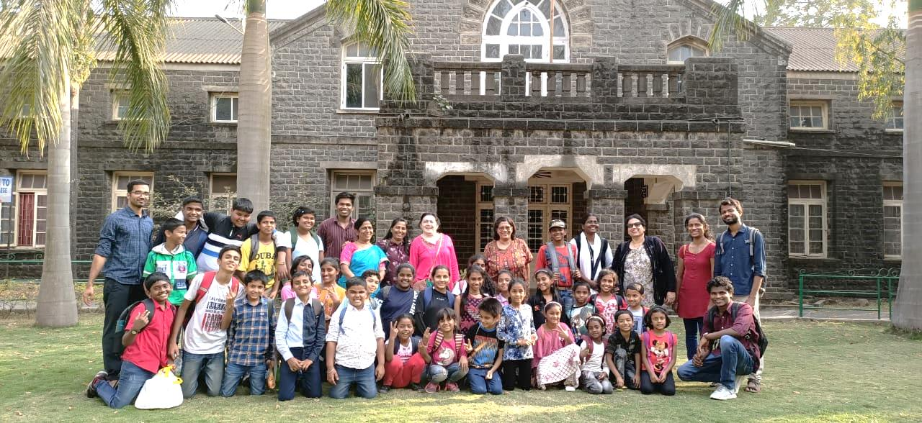This year the Sunday school went for their annual picnic to De Nobili College on 16th February.

Fr. Cyril Desbruslais SJ has been conducting Bible Study classes every week for more than 25 years in the St Vincent’s Fathers residence parlour. Every year the committed bible study group undergoes a sort of live-in intensive bible study programme over a weekend. This year the intensive bible study was conducted by Fr Cyril at PG Block, JDV from 14th-16th February. We have a very passionate senior citizens forum organizing programmes right through the year. The Senior Citizen's Forum held its first meeting on 8th February at the Barco Hall. The prime purpose of the Meeting was the renewal of membership. The response was good and the membership was outdone. On 1st March, the Youth of the Parish organised an outreach program at the Mother Teresa’s Home, Tadiwala Road for all the residents and spent time interacting with them and put up some entertainment program.
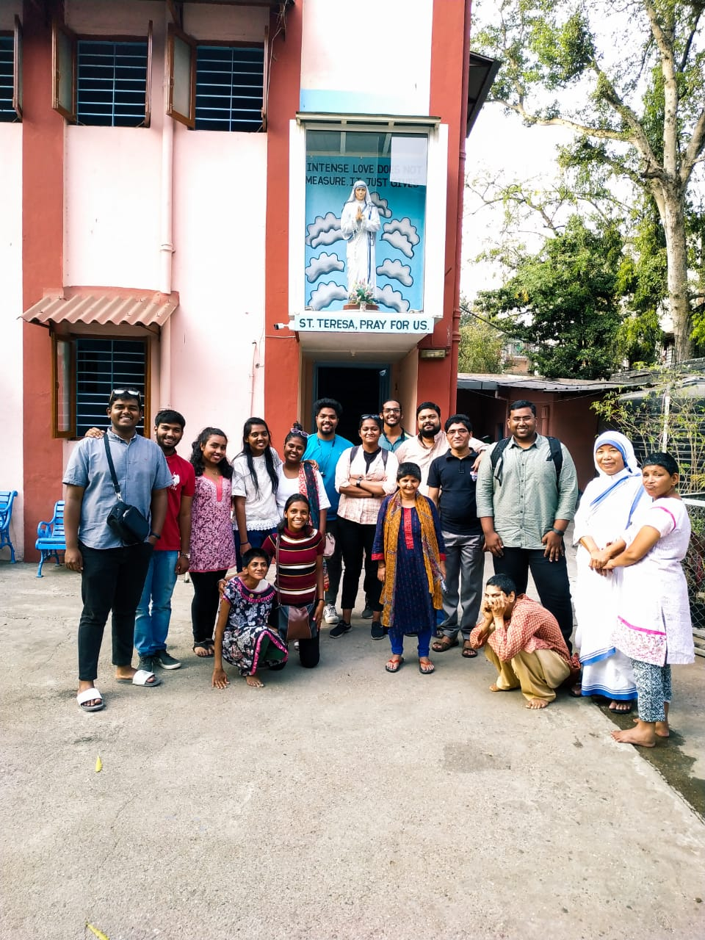
The vibrancy of the parish very obvious from the colourful Parish Bulletin ‘ Voices of St Xavier’s’, that is published every quarter, gives a peep into the life of St Xavier’s Parish.

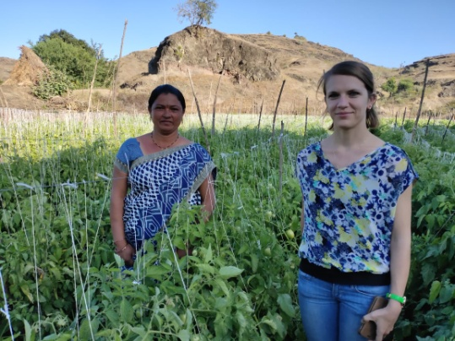
SEMINAR AT PG BLOCK -:

Last month Social Centre had a number of visitors from different organizations visiting our various projects. Besides this, we had a group of people from Vaijapur who came to learn the basics of community development through Watershed management programme. We were happy to have the presence of Ms Sarah from Nuremberg Mission office. She took keen interest to visit our different projects.
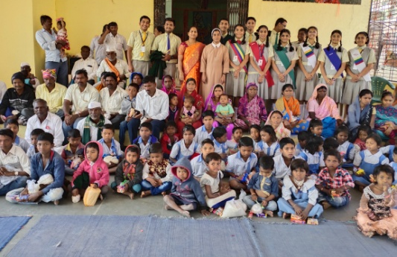
Sacred Heart Convent School children shared their joy with our tribal children in Borwak and Tass villages.
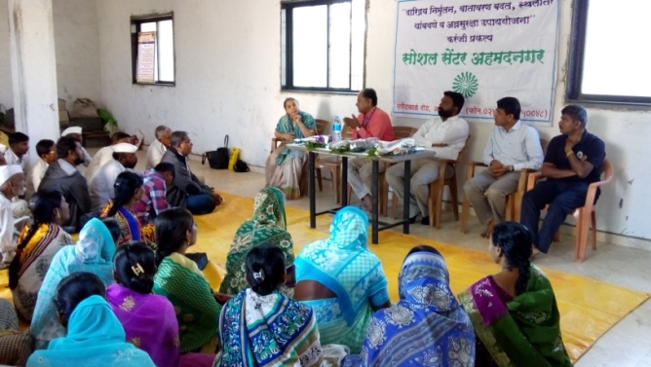
A farmers training programme was organised at Karanji. Mr. Jagtap, DDM, NABARD, Mr. Gaikwad, ATMA Block Coordinator, Mr. Magar, local Agriculture extension officer guided our farmers explaining various Govt. schemes available for farmers and how to set up Farmers Producing Company. After the successful repayment of microfinance in the first phase, seven SHGs have received 14 lakhs more for livelihood intervention from Syndicate Bank, Karanji.
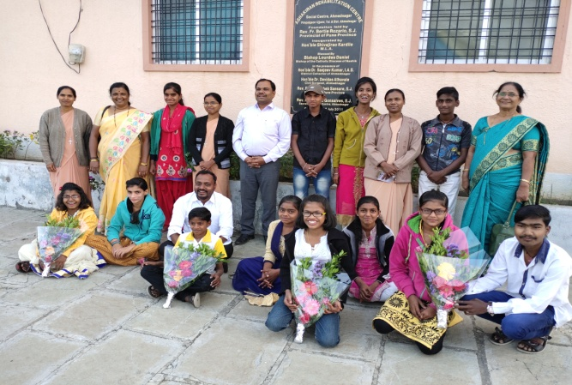
Ashakiran Children keep good health. It continues to receive good support from our different communities and institutions. Special thanks to Fr. Peter Khandagale and Dnyanamata Vidyalaya Staff and students for sharing their joy with these children.

They spent quality time with them. Fr. Cyril Desbruslais and his SSU team have been great support to this institution for the last few years.
The XINRM students had an educational tour to Sindhudurg District. XINRM team at Social Centre called the Green Angels Club conducted a session at St. Xavier's School, Srirampur where they talked about nature and the ways to be a compassionate, responsible citizen.
They gave inputs on photosynthesis and how plants produce their own food. They also took sessions on how to be caring for the planet, importance of loving nature, her beauty, protecting her and working for peace and harmony on this planet. These sessions will be continued every month. We have also invitation from other schools as well. We are grateful to Fr. Titus, Staff and students for their wholehearted support and encouragement.
We are a nation blessed with rich traditions and cultures that people from all over the world visit us to learn about our unity with diversity. Let's join hands with everyone to make this place a better place for everyone to live in.

TIDINGS FROM LOYOLA, PASHAN -:
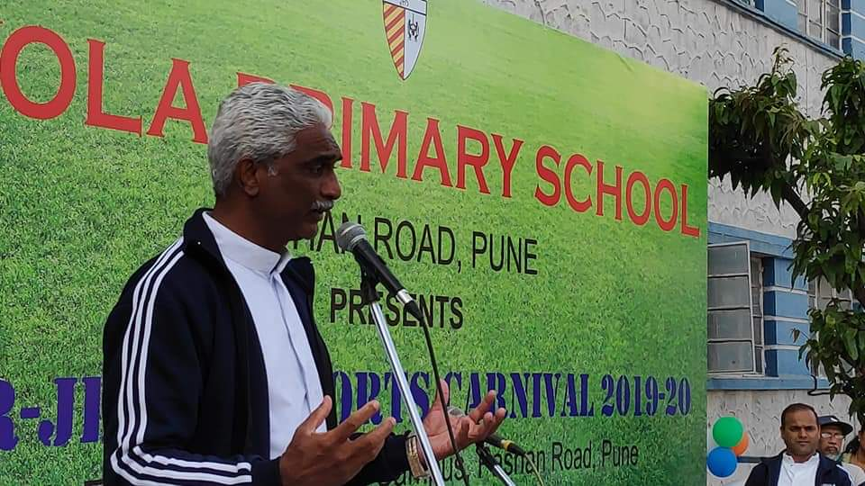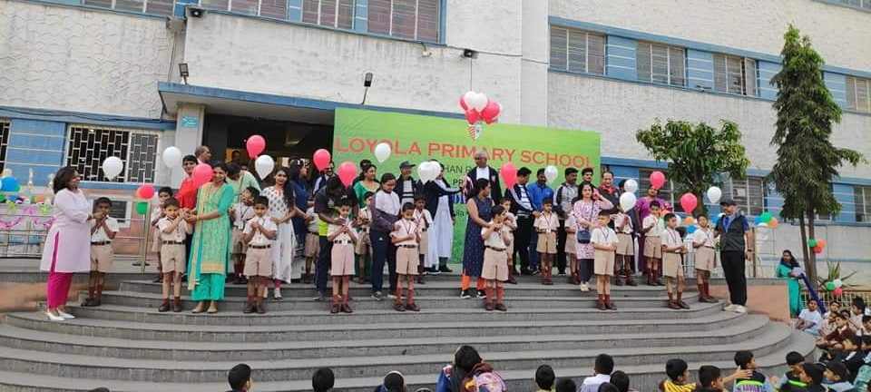The Inter-Jesuit Sports Carnival 2020 at Loyola, Pune was held on 14th February. Fr. Provincial inaugurated the Sports Carnival. In his Inaugural Address he emphasised the purpose Sports Carnival was playing in true spirit of sportsmanship.
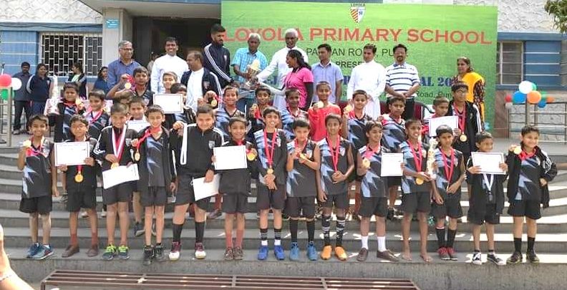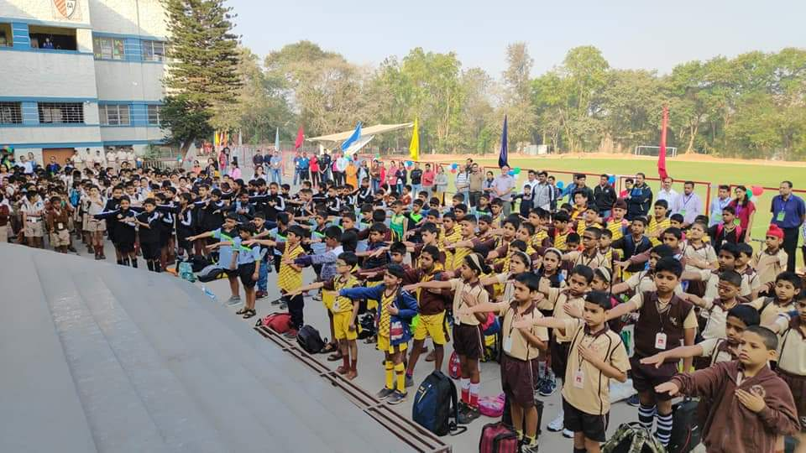It was heartening to witness students, Parents, ELAN and many other school parents supporting and accompanying their children. Coming together and being together elevates our hearts with pride for the celebration of the spirit of sports. Fr. Provincial appreciated the sporting spirit and team spirit of all teams. He motivated them to be consistent and committed in their hard work.

FOOD FESTIVAL AT ST. EDMUND CAMPION PRE-SCHOOL -:

The Pre- School teachers and parents organized Organic food-festival for the Pre-School students, parents and Loyola students. 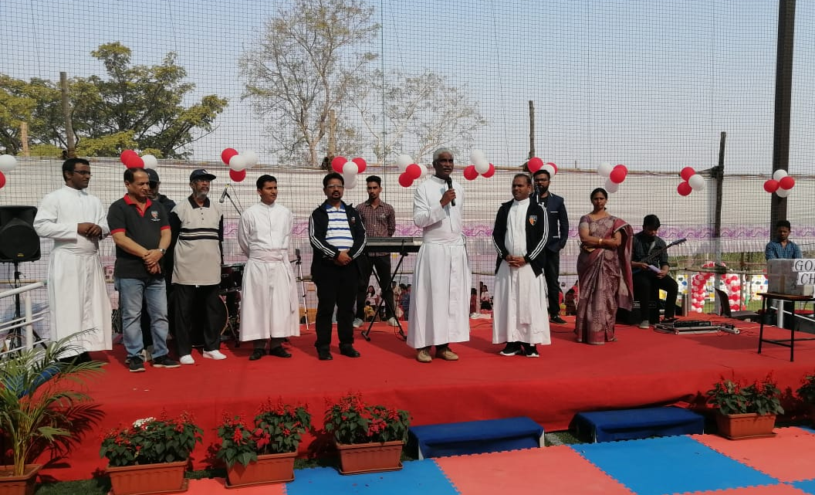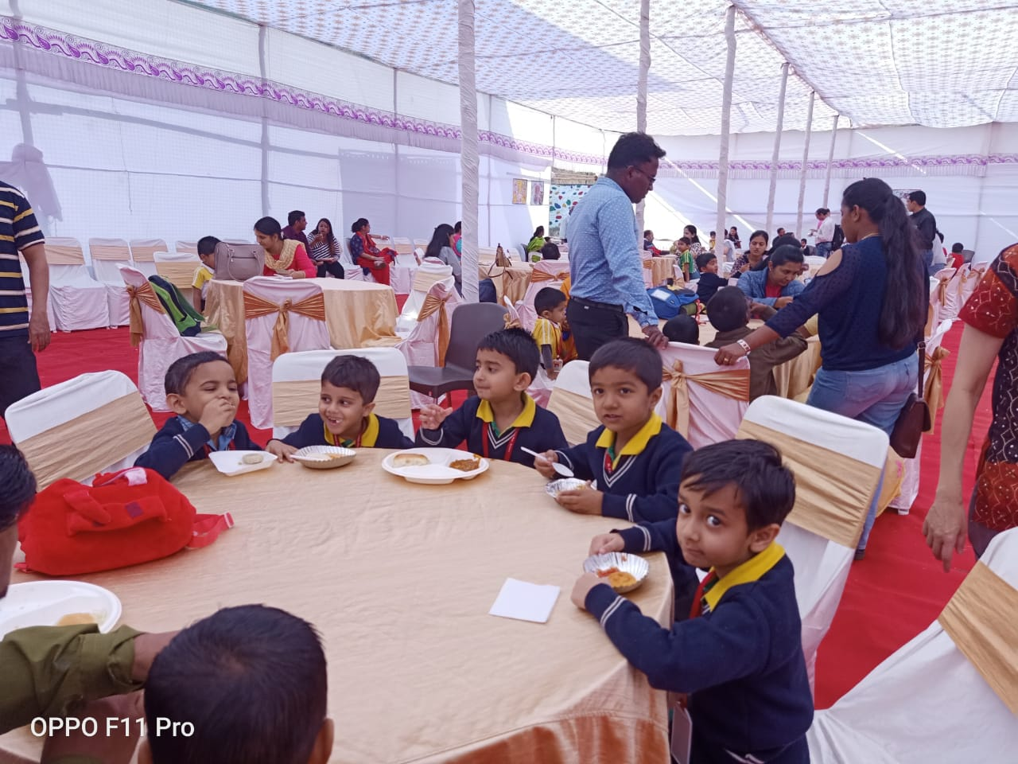It was an occasion for promoting natural food and strengthening the bonding of the parents and the teachers. The parents came forward voluntarily to put up the stalls with mouth-watering delicacies and games. It gave unlimited opportunities to the children to pamper themselves. 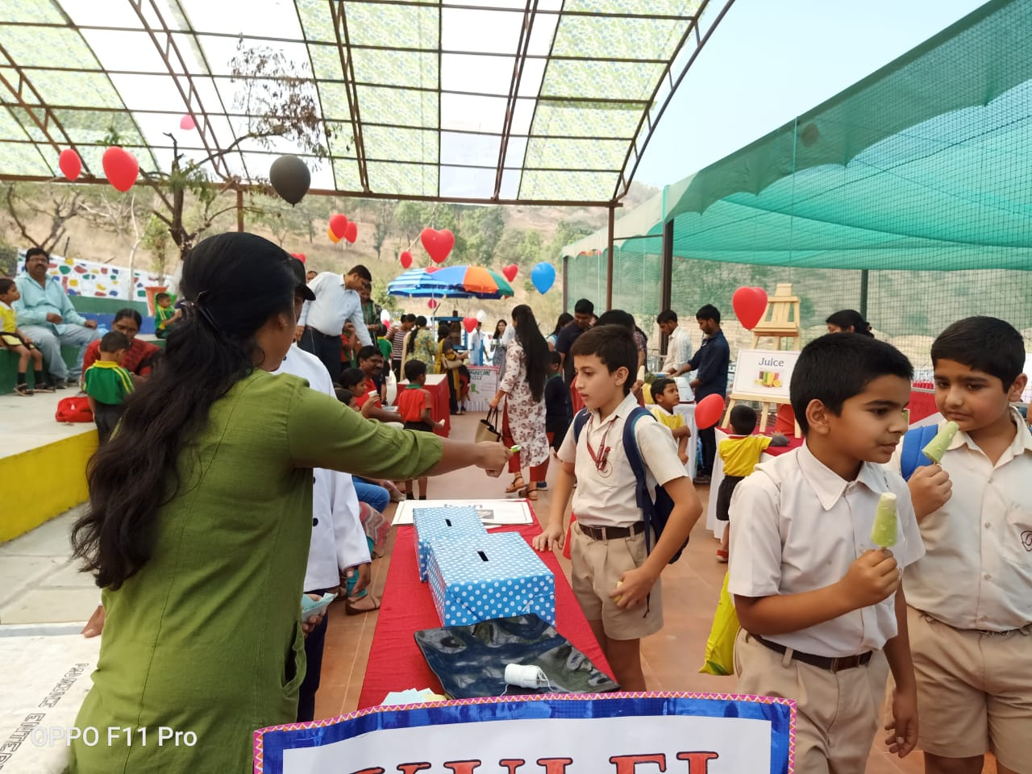

The DJ further elevated the spirits with some well-chosen numbers. The parents were delighted to see their children full of life with song, dance and merry making. We also welcomed Vidyamata School, Shevgaon. It was delightful to see the broad smile on their faces as they enjoyed the event. It was a loving gesture of sharing and caring for all.
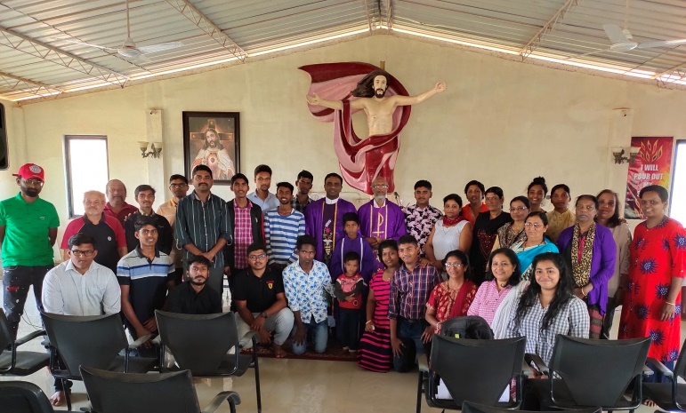
This year the Lenten Season began with prayerful mood and beseeching God’s Blessing on each one of us. On the Ash Wednesday at the beginning of the day we had community Eucharist along with lay people Fr. Sampat celebrated the Mass and preached. During his homily he highlighted the importance of Lent season and also the meaning of sacrifice. For the school children and Staff we had holy Eucharist just at the beginning of the school, where all the Christian Staff and students participated. Fr. Francis D’Souza SJ celebrated the Eucharist. In the evening Fr. Ovid and Fr. Anthony celebrated the Eucharist in St Sebastain’s Church, NDA. Prior to the day Fr. Sampat and Fr. Anthony joined our province members for the ecological workshop held in Gujarat.
Few Parishioners along with our Pre- Novices went for Lenten Retreat at Lord’s Ranch. Fr. Ovid guided the elders and Fr. Anthony guided the youth and the Pre-novices. Sch. Manuel too assisted them. The theme for the Retreat was Self-Renewal in relation with God, Others and Nature. During the Retreat we had Ecological Way of the Cross, Ecological Mass in the Nature, Adorations, Walking Rosary in different languages, Morning meditation, Nature walks, personal interviews with the priests and bonfire having interaction and question answer session. 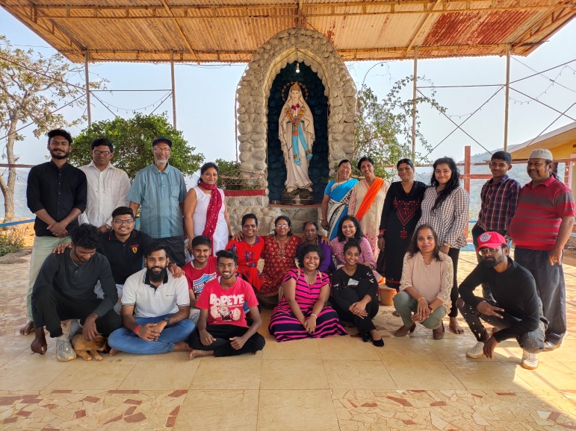The Retreatants were enriched with profound and unique experience and were glad that they had time to spend with God and Nature. This also helped them to build their bonds of love and care among themselves. We are grateful for the care and the stay they were given by the hospitality of those at the Ranch.
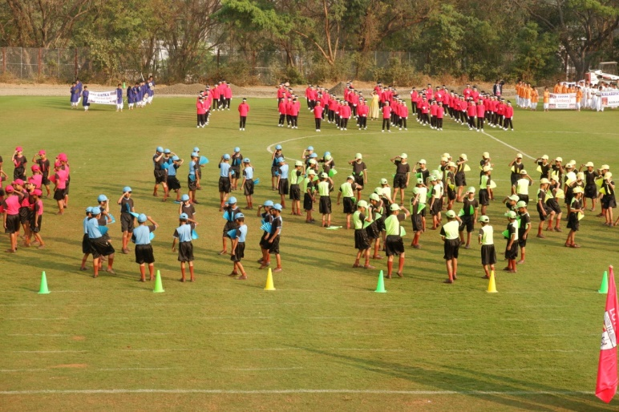
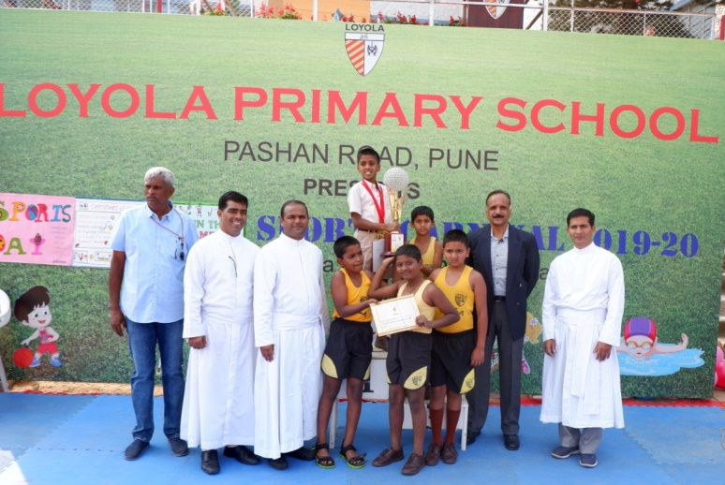The last day of February witnessed the Annual Sports Day of Primary section. Mr. Ajay Nalawade Entrepreneur and Member of MCA was the chief guest. He also gave away the prizes. The students performed different drills which highlighted their Unity and the tremendous practice they had prior to the day. The entire program was well planned and executed. Anthony Tribhuvan SJ

THE DAUGHTERS OF VINCENT’S -:
“What’s a queen without her king? Well, historically speaking, MORE POWERFUL”
Vincent’s is a culture, it’s an attitude which over the past 150 years was very proudly owned by the boys, but now it’s been gracefully carried forward by the girls of St. Vincent’s. Since we opened our doors to the girls, the question now was…. How to participate in International Women's Day? But how about doing something different this time and be a little unpredictable? Like Paula Abdul, the famous American singer once said, “When people expect me to go right, I’ll go left. I am unpredictable.” So, how does celebrating womanhood sound to you? 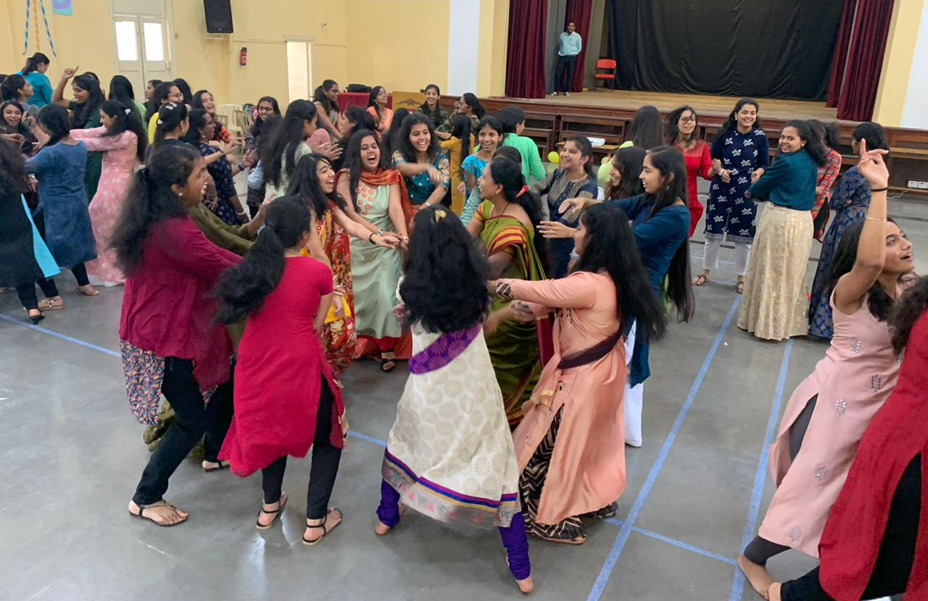With the permission, approval & blessings of the Principal Fr. Francis Patekar & the Vice Principal Fr. Vikram Shingare, the right ingredients and spices were added which made the flavour of this day absolutely memorable.
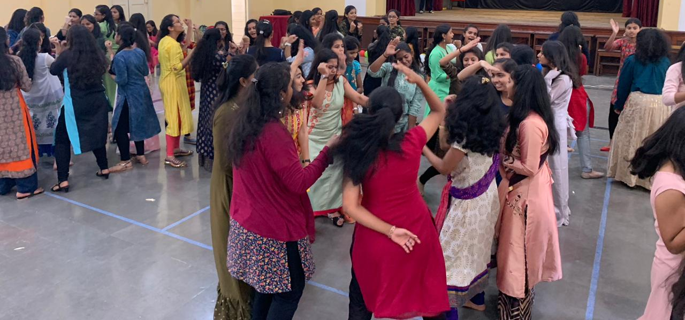The 4th of March started off as any other ordinary day. The gates of the school opened & Vincentians in their brown uniform started to pour in. The pleasant surprise was when instead of the regular brown, colours started to enter the gates. Our young ladies were so beautifully dressed in Indian attire. They carried themselves well. The day commenced with the regular Assembly where amidst the uniforms there was an array of flamboyant colours. The girls enjoyed the limelight & attention being the queens of the day while attending the regular classes & lectures. The day all of a sudden went from being normal to extra ordinary!
After college there was a surprise for the girls in our very own Gulati Hall. The hall was decorated with streamers & balloons, all ready for the party to start. The Chief Guests were Supervisor of the High School Mrs. Diniz & Supervisor of the Primary Mrs. Cabral. The programme started with welcoming & introductions; the girls gave a speech & also put up a peppy dance number. They were shown inspirational & motivational videos to keep that spark in them burning. That day Vincent’s taught them to be strong women, not with attitudes but with standards. She will learn to love herself first & shine amongst those who never believed she could.
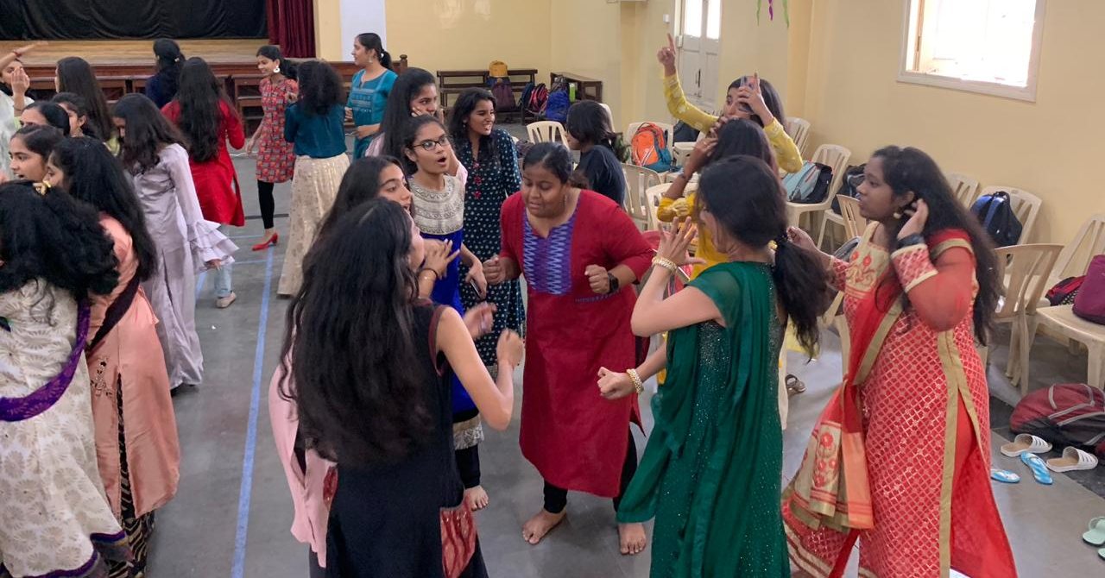
The day ended with a bang where our girls after refreshments danced like no one was watching. The genres of songs ranged from English hip hop to Bollywood all the way to the famous Marathi ones. The girls danced not knowing what the future holds but, putting each step forward with grit anchored in grace. One thing is for sure, Vincentian girls are always going to shine, stand out & be above the rest. They will be stilettoes in a world of flats!
She will rise with a spine of steel & a roar like thunder, she will rise.
Miss Nazneen Irani

ST. XAVIER’S GEORAI -:

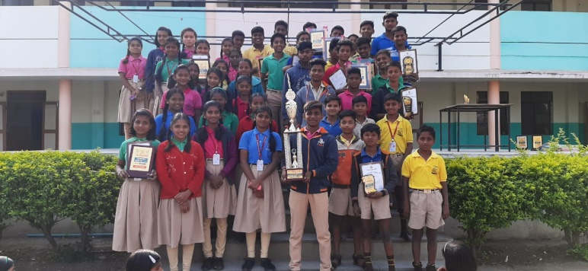Georai Nagar Palika had organised sports and cultural program competition. Our Saint Xavier School actually participated. Primary and secondary students performed excellently. The school won the championship trophy for the seventh time. It is the school record. The students participated enthusiastically and won 75 per cent of prizes in individual and group competition. The school is scaling new height in both academic sports and cultural events under the able leadership of Fr. Ratnakar Dushing.
St Ignatius of Loyola parish organized a one Lent Recollection for the faithful. Fr. Michael Anthony guided the faithful in reflection prayers, Adoration and Confession. He enlightened the minds and hearts by sharing his reflection on fasting prayer and offerings. The faithful were happy to get spiritual awakening and could renew their spiritual commitment. The faithful contributed towards the meaningful, productive and spiritual awakening.

HOLY SPIRIT PARISH, SHEVGAON -:
We celebrated Eucharist in each Mass Centre of our parish, irrespective of protestant pastors’ presence and activities. Many Catholics in several villages and Vastis were unaffected by their Protestant brethren. The faithful participated in the liturgy in good number. As a remote preparation for the Easter, instead of going to other Parishes or cities we planned this year’s devotion of the Way of the Cross in our parish villages. We carried three laminated sets of the Way of the Cross pictures. All the three Jesuits along with the Sisters from Nityaseva and Anand Nivas reached three different villages. Each house in those respective villages participated in the Passion Path of Our Lord. The villages were reached on the days except Wednesdays and Fridays. On these two days we conducted the Way of the Cross in Parish Zones of the Shevgaon town area.
Annual Sports Day of Vidyamata School:
The Annual Sports Day was celebrated in the Vidyamata English Med. High school Campus. The entire school was enthused. The Prize distribution was done on the Republic Day as part of the Day’s programme. Of course the Big day for the School was travel to Pune Jesuit Sports Carnival at the Loyola and food festival at Edmund Campion Pre-School. 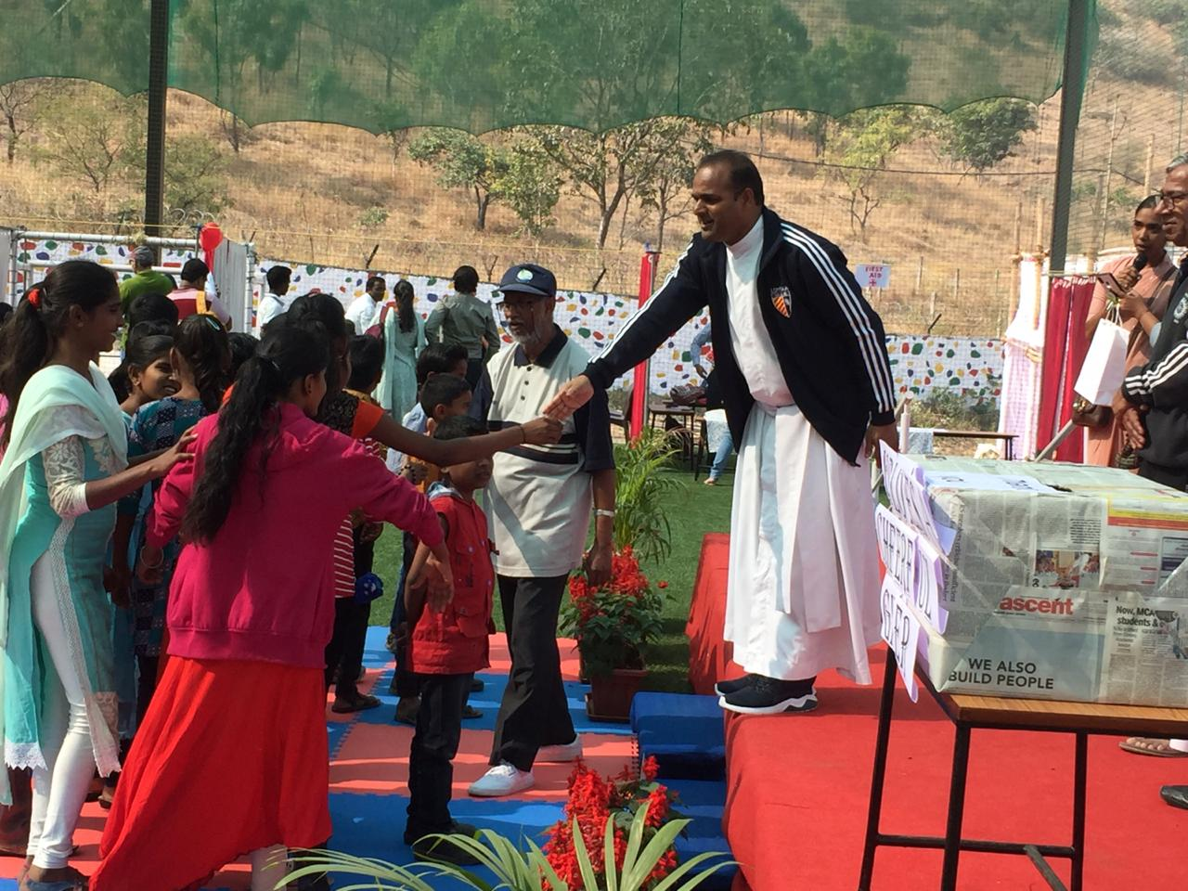Many of the students had been to Pune city and to such a high standard School the first time. The Children enjoyed themselves to their hearts content.

Boarding:
Our boarders though few were encouraged to keep the surroundings clean. They lent their hand in Church work apart from the works that were done by the girls and Sisters of Anandnivas. All our boarders are from the rural Marathi Schools. Hence we, i.e Mr. Sagar Gajbhiv, Fr. Anil, Fr. Valente and Fr. Mathew interacted in English with the boarders. This has made them bold to make efforts to speak English. Now they have reached the stage where they can follow most of what we speak. Due to lack of vocabulary they anglicise Marathi words and a lot of laughter is created. Fr. Anil has also started extra English Grammar classes for 6th & 7th STD boarding boys. Of course, these classes were also open to the neighbouring students of the Vidyamata.

Parish Initiative for Public Safety:
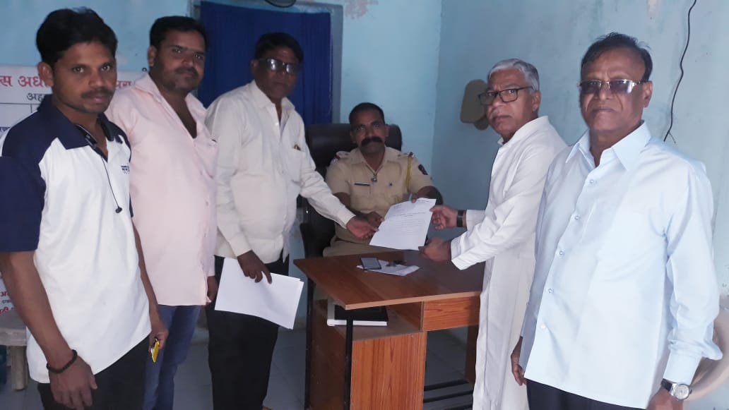 The front of Shantinivas Road is a dangerous junction. Here the roads from Shevgaon going to Beed, Georai and Paithan - a religious pilgrim place meet. The junction is rather busy 24/7. In the past several fatal accidents in front of our Parish entrance claimed number of lives. Recently three persons died at the same junction. As the Nityaseva Hospital gate opens on to the main junction road, the administration tried several times its level best in the past to get the City Municipality to build speed breakers, but to no avail. Finally, after the recent gruesome accident & three deaths, the Parish Priest Fr. Valente, Mr. Prakash Waghmare - the local active member of the Local CNI Church and a few others approached the Municipal authorities with an application and an ultimatum to demand speed breakers within three days. As we were ready to take a big protest Road blocking rally, the Municipal Authorities constructed long overdue speed breakers overnight.

Ignatian Spirituality at Divyavani.
Fr. Prakash Bhalerao readily offered himself to conduct the Ignatian course. From our Parish, Sisters, women catechists, male catechist and a few Parish Council members attended the Course. Fr. Subhash did well to provide TA & food.

Meeting of the District Jesuit Pastors.
In the month of February the District Jesuit Superior convened a meeting of all the Jesuit Pastors. Shevgaon, being the convenient & central place, the Pastors came here. There were a lot of concerns and ailments of various parishes voiced by our Brothers. It was a good and open sharing.

Three Religious Communities:
As usual, every two months all the three communities meet for a Recollection, evaluation of our apostolates and a fraternal agape. In the last week of the last month that is February 2020, before the Ash Wednesday, we three communities celebrated togetherness

TOWARDS AN APOSTOLIC PLATFORM- ECOLOGY WORKSHOP AT NADIAD -:
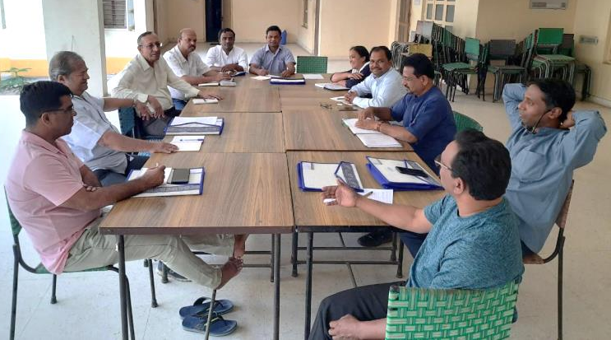Ecology and spirituality are fundamentally connected because deep ecological awareness ultimately is spiritual awareness. This is very true in our lives’ cause each one of us beginning from Farmers till the richest businessmen is connected and dependent on nature. So to care for our common home to form a common network, the different representatives from the four provinces of Western Zone gathered in Pastoral Centre to discuss about ways and means where we can serve and care for Nature. The workshop was titled as towards an apostolic platform. Fourteen of our province men were part of this great historical event. The workshop was well planned and implemented by the four PDD of the four provinces and hosted by Gujarat Province.
The workshop began with introduction and the explanation of the dynamics of the workshop in the presence of all the four Provincials. Fr. Andrew Fernandes, SJ, Our Provincial in his inaugural address spoke about the wrath of the Nature which takes place every year and how it is reaching close to us. He also highlighted the different ways in which the great personalities are making efforts to work for the ecology. 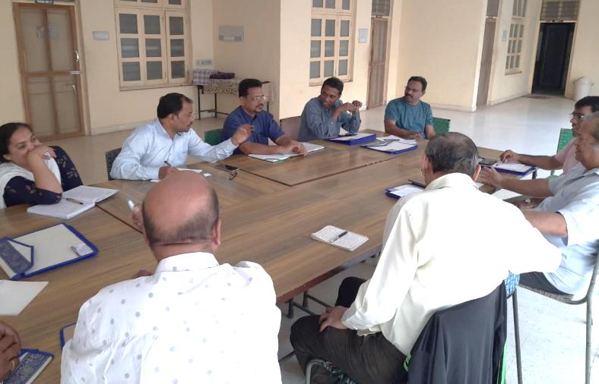Later during the workshop initially we were divided in province wise groups to see how each province is involved in the work of ecology. During the workshop the method of spiritual conversation was followed. Each province was given a chart to portray their works and present them.
As the workshop was in progress the group was divided in mix groups to discuss the priorities and possibilities, that we can have common networking among the Western Zone. The house came to common consensus in ways that there could be networking. Then there was discussion on the strategies and ways we can implement. The major ways that were finalized are- 1. Linking the educational institutions, eco-spirituality, life-style 2. Conservation of Natural Resources, environmental awareness and training. 3. Research and advocacy 4. Sustainable energy.
During this workshop there was Mass in and with Nature, Release of Book names Sparsh complied by Fr. Rappai and Fr. Lancy. At the conclusion once again the members gathered in their province rooms and later gathered the fruits of the workshop.
Anthony Tribhuvan SJ

BIRTHDAYS

MARCH
20 Peter D’Cruz
24 Alfred Benjamin
25 ANDREW FERNANDES
27 Walter Saldanha
APRIL
02 Simon Shingare
14 Anil Chakranarayan
15 Rushikesh Makasare

REMEMBER THE DEPARTED IN YOUR PRAYERS

Fr. Edwin Rasquinha (91/60 BOM) passed away on 20.02.2020 at Andheri, Mumbai.
Fr. Felix Tirkey (52/28 DUM) passed away on 02.03.2020 in Bathbanga, Jharkhand.
Fr. Geoffrey Michael Meagher (77/59 HAZ) passed away on 05.03.2020, in Kolkata.
Fr. Arakal Jacob (96/75 AND) passed away on 12.03.2020, in Hyderabad.

KINDLY MARK YOUR DIARY

- Province Holidays will be held from 14th May to 16th May at Loyola, Pashan, Pune.

- 15th May to 30th May 2020 for Annual Scholastics Retreat, Province holidays and Scholastic summer holidays.

Ad MajoreM Dei Gloriam

@Copyrights reserved. for private circulation

